Weekly Agenda
Monday March 5, 2018
Group Meeting | Review Classroom Daily Schedule; Review Calendar; Review and Record Number of Day of School.
Reading | Practice letters; leveled sight words by groups.
Math | Classwork:  Practicing Position Words  Determining Area  Home Work: Subtracting numbers 0-20 using picture symbols and checking math using a calculator.  Determining Area
Snack | Eat snack. Please bring one from home.
Gym | Change before and after gym  Attend Gym with Mr. Wood
Lunch
Hygiene/  Life Skills Jobs | Students participate in their life skills jobs and hygiene groups.  Mrs. Nichols will be taking students for small speech groups.
Journaling | Pre-Primer Words First Grade Words  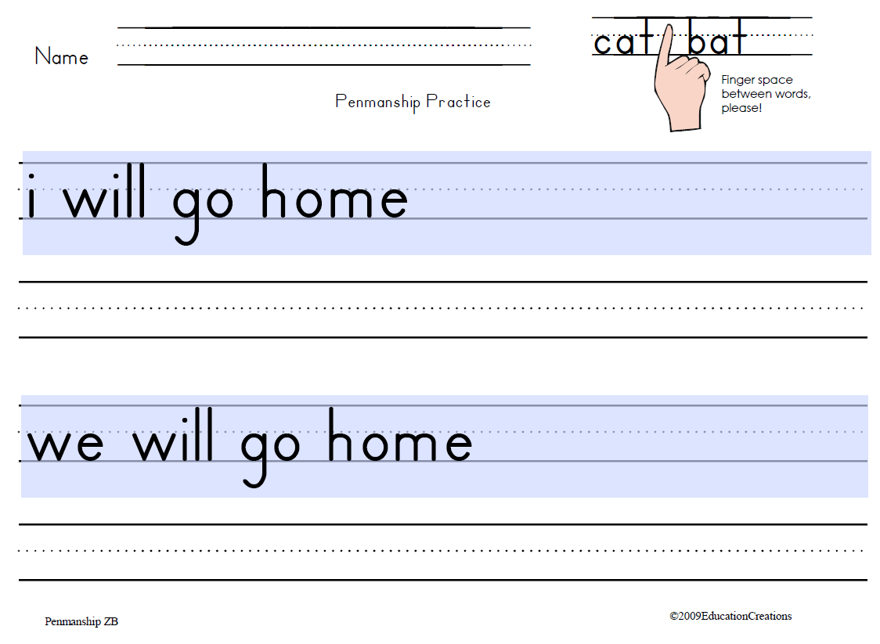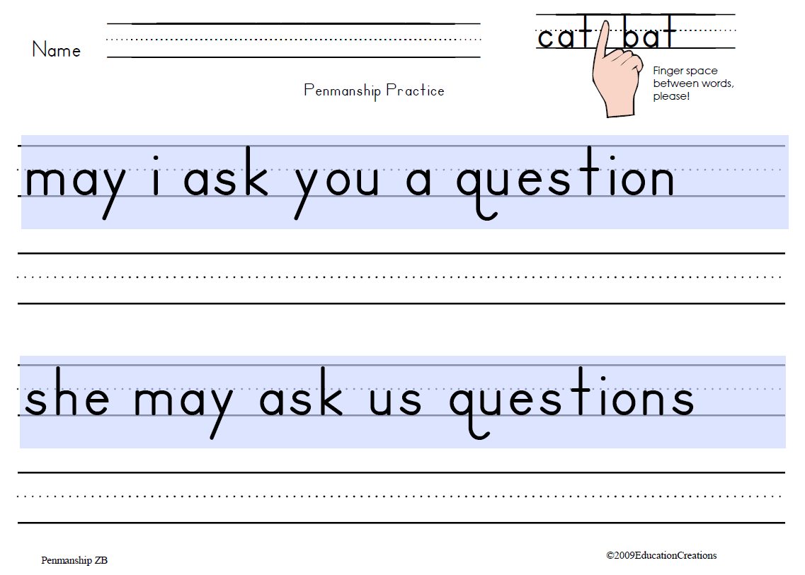  Review Starting Sentences w/Capitals, spacing between Words, Ending with Periods.
Skillstreaming | Reviewing Characteristics of a Friend
End of Day Routine | Access mailbox; fill out today at school; access locker; prepare to go home.

Weekly Agenda
Tuesday March 6, 2018
Group Meeting | Review Classroom Daily Schedule; Review Calendar; Review and Record Number of Day of School.
Reading | Practice letters; leveled sight words by groups.
Math | Classwork:  Practicing Position Words  Determining Area  Home Work: Subtracting numbers 0-20 using picture symbols and checking math using a calculator.  Determining Area
Snack | Practicing Position Words
Gym | Change before and after gym  Attend Gym with Mr. Wood
Lunch
Hygiene/  Life Skills Jobs | Students participate in their life skills jobs and hygiene groups.  Mrs. Nichols will be taking students for small speech groups.
Journaling | Review Starting Sentences w/Capitals, spacing between Words, Ending with Periods.  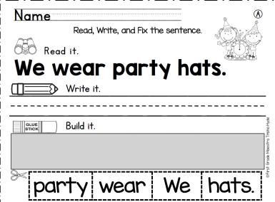
ELA | Writing Folders Writing name, address, phone number
End of Day Routine | Access mailbox; fill out today at school; access locker; prepare to go home.

Weekly Agenda
Wednesday March 7, 2018
Early Dismissal 1:55 p.m.
Group Meeting | Review Classroom Daily Schedule; Review Calendar; Review and Record Number of Day of School.
ELA | Writing Folders Writing name, address, phone number  Practice letters; leveled sight words
Snack | Eat snack. Please bring one from home.
Gym | Change before and after gym  Attend Gym with Mr. Wood
Lunch
Hygiene/  Life Skills Jobs | Students participated in their life skills jobs and hygiene groups.
Journaling | Build a sentence by unscrambling the sentence.  Cut, color picture and print sentence.
End of Day Routine | Access mailbox; fill out today at school; access locker; prepare to go home.

Weekly Agenda
Thursday February 22, 2018
Group Meeting | Review Classroom Daily Schedule; Review Calendar; Review and Record Number of Day of School.
ELA | Whole group lesson: Read News-2-You (learning to read Informational Text).  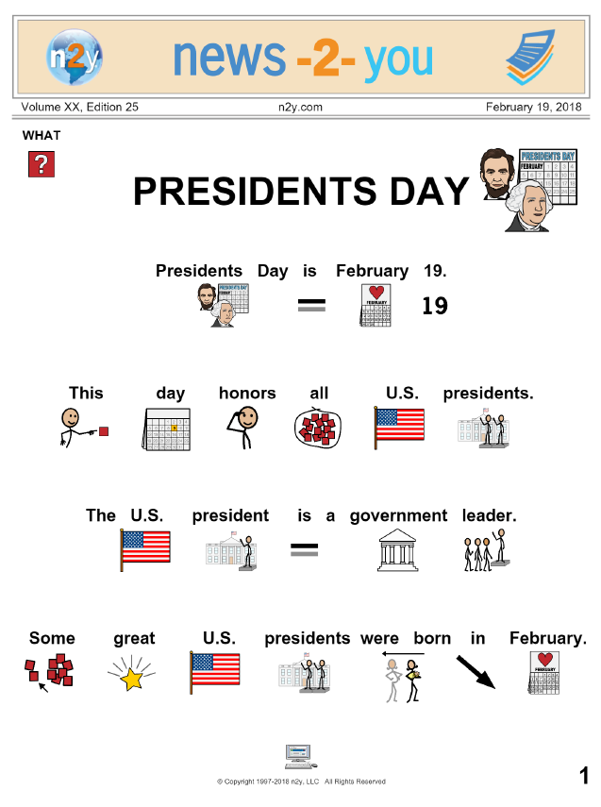  Answer Comprehension Questions. Assessment  Complete individualized pages.  Journal; dot-to-dot
Snack | Eat snack. Please bring one from home.
Gym | Change before and after gym  Attend Gym with Mr. Wood
Lunch
Hygiene/  Life Skills Jobs | Students participated in their life skills jobs and hygiene groups.
Journal | Complete Read and Do page from News-2-You
End of Day Routine | Access mailbox; fill out today at school; access locker; prepare to go home.

Weekly Agenda
Friday March 9, 2018
Group Meeting | Review Classroom Daily Schedule; Review Calendar; Review and Record Number of Day of School.
ELA | Chromebook Moby Max  Personalized Work
ELA | Color Sight Words
Snack | Eat snack. Please bring one from home.

